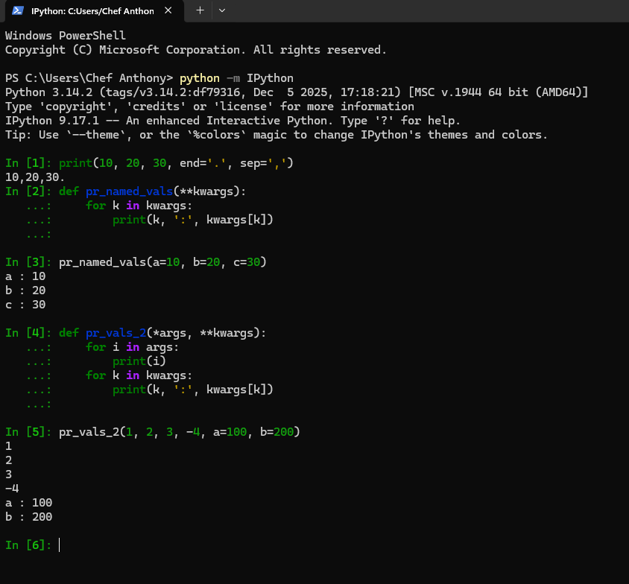
Advantages of using **kwargs
- Functions using **kwargs can take any arbitrary number or keyword argument without requiring changes to the functions signature. This enables backward compatibility when adding new optional parameters to a code base over time.
- Decorators and wrapper functions can accepts *args and **kwargs to cleanly pass positional keyword arguments down to the wrapped target functions without needing to inspect or duplicate the underlying signature.
- When working with functions that handle dozens of potential parameters (such as GUI components or database query builders), **kwargs gets rid of the need for exhaustive lists of defaulted parameters in the signature.
Disadvantages of using **kwargs
- Because **kwargs accepts arbitrary keyword names, static type checkers and IDE autocompletion tools that I love so much can’t suggest valid parameters names or enforce expected data types without extra rules like TypedDict.
- The function signature loses self-documentation. Developers that inspect the function signature cannot determine which keywords are valid, required, or ignored without reading the implementation, docstrings, or source code.
- Misspelled argument names will not raise a TypeError at the call site. Instead, its stored in kwargs and ignored unless logic to validate keys is implemented.

